

**Brandon Hobbs**

**DAD-220**

**March 10, 2022**

**Module 4 Lab**

1. **Retrieve employee tuples and identify the number of employees** in San Francisco and New York.

1. **Retrieve order details for orderNumber** 10330, 10338, and 10194 and **identify what type of cardinality this represents in the entity relationship model.**
   1. Graphical user interface

      Description automatically generated
   2. This is a one-to-many as there can be many orderdetails and only one order
2. **Delete records** from the payments table where the customer number equals 103.
   1. Text

      Description automatically generated Text

      Description automatically generated with medium confidence
   2. Timeline

      Description automatically generated
3. **Retrieve customer records** for employee Rep Barry Jones and **identify** if the relationships are one-to-one or one-to-many**.**
   1. 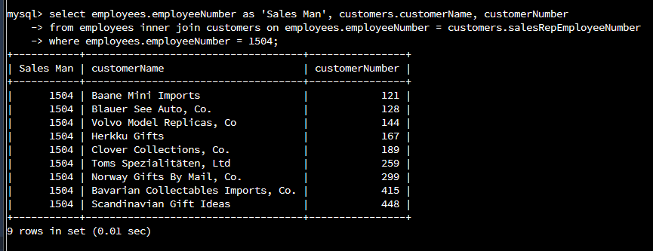
   2. This is a one-to-many relationship. There is only a single employee with ID 1504, even of there are many Barry Jones, and he has many customers. The many customers have one sales rep.
4. Retrieve records for customers who reside in Massachusetts, then identify their sales rep and the relationship of entities. Identify if these entities demonstrate one-to-one or many-to-many relationships.
   1. Graphical user interface, text

      Description automatically generated with medium confidence
   2. This is a many-to-one relationship. There are many customers in MA but each has only one sales rep – that is there is one sales rep to many customers.
5. Add one customer record with your last name using an INSERT statement. You may use the name of a celebrity or fictional character if you don’t use your own name.

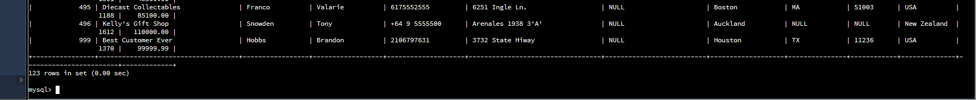

1. **Reflection**
   1. **Define how cardinality** is applied to the databases you’ve been working with and why different numbers of records returned from the different offices.  
        
      The databases have multiple cardinality values across the different tables. For example, there are zero or many products but they belong to one and only one product line. A customer may have zero or one payment but each payment has one and only one customer.  
        
      An employee can only belong to one and only one office but each office may have zero or many employees. It is because of this many-to-one (employees-to-offices) relationship that allows each office to return a different amount of employees.
   2. **Compare and contrast** the different queries you ran and how cardinality applies to them.  
        
      Some of the queries were one-to-many and some were many-to-one. For example, the query for rep Barry Jones showed that he has many clients. Whereas the query for customers in MA and their sales showed that many clients can have a single sales rep.
   3. **Describe two of the crucial benefits** of cardinality in this type of database.
      1. They give a hint about use of a foreign key as well as where the foreign key should reside. That is, if I want to have a relationship between two tables it should be implemented the as foreign key on 'many' side. Many-to-many relationships are new dependent tables. Etc.